WEEK 2: PENETRATION TESTING BASICS

Fig 1: Nmap port scanning
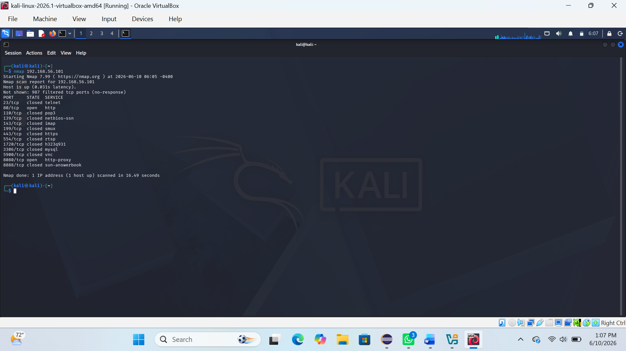

Fig: 2 Detailed scan
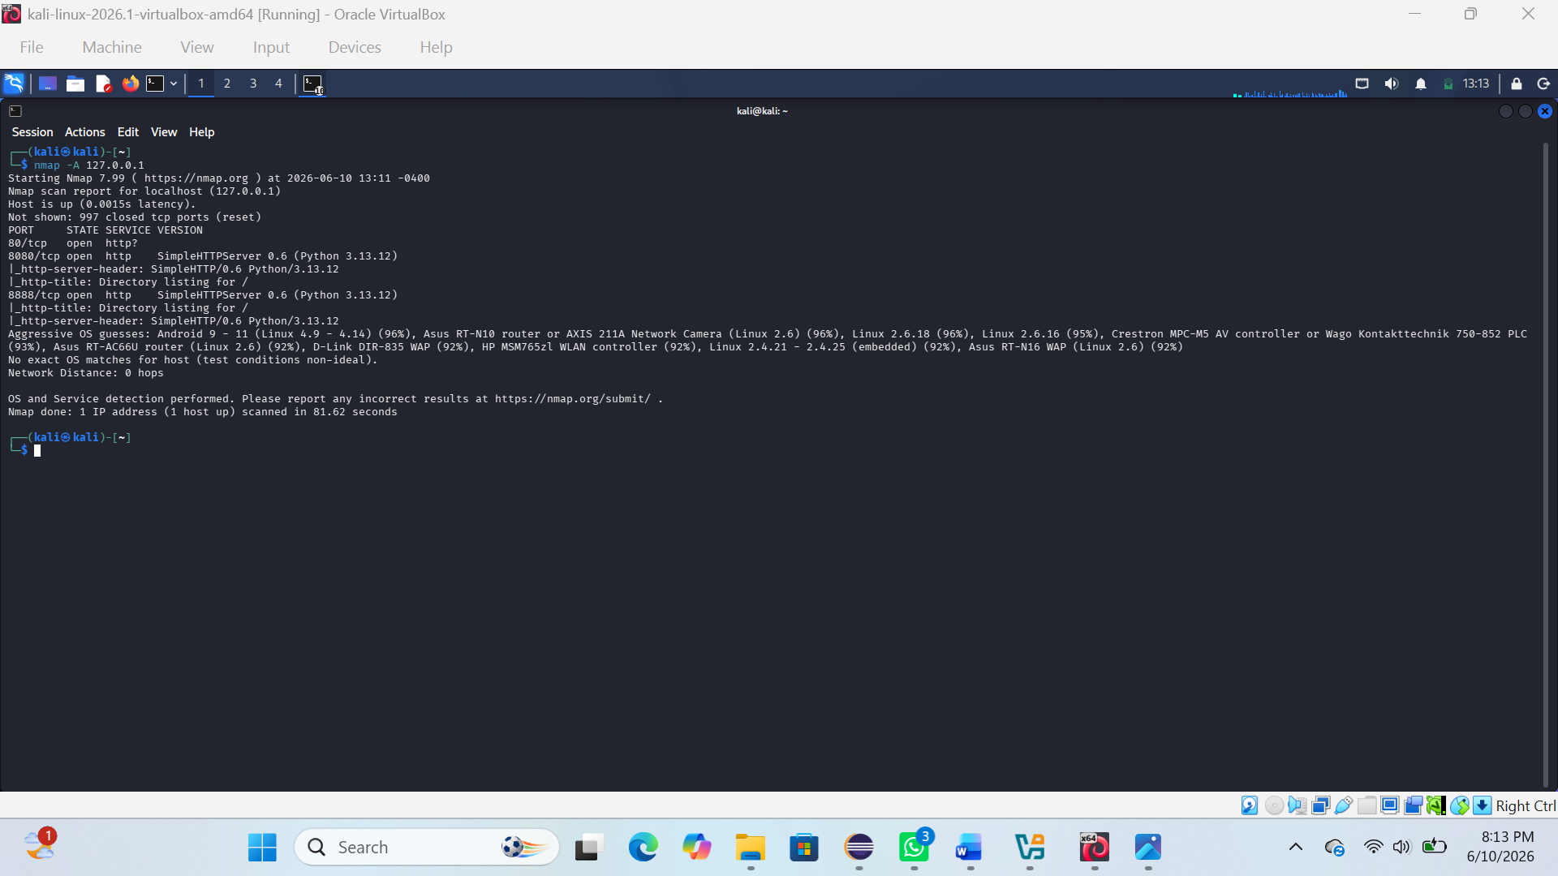

REFLECTION:
I learned basic penetration testing concepts and how tools like Nmap are used to identify open ports and services on a target system

